11.1.13 Editors - Compositor Editor - Header - Add Menu - Distort
Detailed table of content 1
Add menu - Distort 4
Corner Pin 4
Crop Node 5
Displace Node 5
Flip Node 6
Lens Distortion 6
Map UV 7
Movie Distortion 8
Plane Track Deform 9
Rotate Node 10
Scale 11
Stabilize 2D 12
Transform 12
Translate 13

Detailed table of content
Detailed table of content
Detailed table of content 1
Add menu - Distort 4
Corner Pin 4
Inputs 4
Image 4
Corners 4
Outputs 4
Image 4
Plane 4
Crop Node 5
Inputs 5
Image 5
Properties 5
Crop Image Size 5
Relative 5
Crop Region Values 5
Outputs 5
Image 5
Displace Node 5
Inputs 5
Image 5
Vector 5
Scale X, Y 6
Outputs 6
Image 6
Flip Node 6
Inputs 6
Image 6
Properties 6
Axis 6
Outputs 6
Image 6
Lens Distortion 6
Inputs 6
Image 6
Distort 6
Dispersion 7
Properties 7
Projector 7
Jitter 7
Fit 7
Outputs 7
Image 7
Map UV 7
Inputs 7
Image 7
UV 7
Properties 7
Alpha 7
Outputs 8
Image 8
Movie Distortion 8
Distortion vs Undistortion 8
Calculating Distortion 8
Inputs 8
Image 8
Properties 9
Movie Clip 9
Distortion Method 9
Undistort 9
Distort 9
Outputs 9
Image 9
Plane Track Deform 9
Properties 9
Movie Clip 9
Object 9
Track 9
Motion Blur 10
Samples 10
Shutter 10
Outputs 10
Image 10
Plane 10
Rotate Node 10
Inputs 10
Image 10
Degr 10
Properties 10
Filter 10
Nearest 10
Bilinear 10
Bicubic 11
Outputs 11
Image 11
Scale 11
Inputs 11
Image 11
X, Y 11
Properties 11
Space 11
Relative 11
Absolute 11
Scene Size 11
Render Size 11
Stretch, Fit, Crop 11
X, Y 11
Outputs 12
Image 12
Stabilize 2D 12
Inputs 12
Image 12
Properties 12
Movie Clip 12
Filter 12
Invert 12
Outputs 12
Image 12
Transform 12
Inputs 12
Image 12
X, Y 13
Angle 13
Scale 13
Properties 13
Filter 13
Nearest 13
Bilinear 13
Bicubic 13
Outputs 13
Image 13
Translate 13
Inputs 13
Image 13
X, Y 13
Properties 14
Relative 14
Wrapping 14
Outputs 14
Image 14

Add menu - Distort
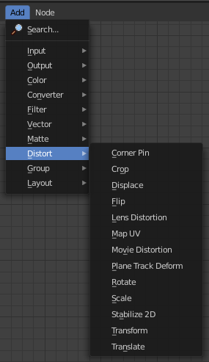
These nodes distort the image in some fashion. They work either on the whole image, or by using a mask to vary the effect over the image.

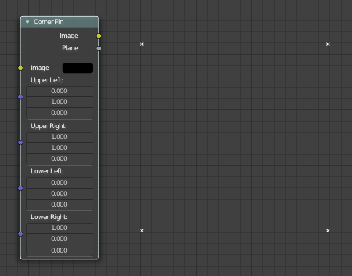
Corner Pin
The Corner Pin node uses explicit corner values for a plane warp transformation. It works like the Plane Track Deform node, but without using “plane track” data from the Movie Clip Editor.

Inputs

Image
Standard image input.

Corners
Four vector inputs to define the plane warping. (Z component of vector inputs is ignored.)

Outputs

Image
Standard image output. (The image after distorting.)

Plane
A black-and-white alpha mask of the plane.

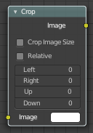
Crop Node
The Crop Node takes an input image and crops it to a selected region.

Inputs

Image
Standard image input.

Properties

Crop Image Size
When enabled, the image size is cropped to the specified region. When disabled, the image remains the same size, and uncropped areas become transparent pixels.

Relative
When enabled, crop dimensions are a percentage of the image’s width and height. When disabled, the range of the Crop Region Values are the width and height of the image in pixels.

Crop Region Values
Define borders of the crop region. Lower, upper, left, right.

Outputs

Image
Standard image output.

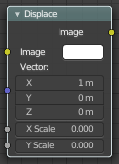
Displace Node
The Displace Node displaces the pixel position based on an input vector.
This node could be used to model phenomena, like hot air distortion, refraction's of uneven glass or for surreal video effects.

Inputs

Image
Standard image input.

Vector
Input of the displacement map. If the a color output is implicitly converted in the vector input, the first channel (red) value determines displacement along X axis. The second channel (green) the displacement along Y axis. If the input is a greyscale image, where both the channel values are equal, the input image will be displaced equally in both X and Y directions.

Scale X, Y
Separate scaling of the vector input in X and Y direction. Acting as multipliers by increasing or decreasing the strength of the displacement along their respective axes.

Outputs

Image
Standard image output.

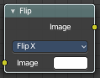
Flip Node
This node flips an image at defined axis.
You can use this node to just flip or use it as a part of mirror setting. Mix half of the image to be mirrored with its flipped version to produce mirrored image.

Inputs

Image
Standard image input.

Properties

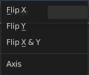
Axis
This can be either X or Y. Also, flipping can be done on both X and Y axis simultaneously.
Flip X, Flip Y, Flip X & Y

Outputs

Image
Standard image output.

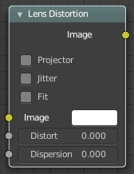
Lens Distortion
Use this node to simulate distortions that real camera lenses produce.

Inputs

Image
Standard image input.

Distort
This creates a bulging or pinching effect from the center of the image.

Dispersion
This simulates chromatic aberrations, where different wavelengths of light refract slightly differently, creating a rainbow colored fringe.

Properties

Projector
Enable or disable slider projection mode. When on, distortion is only applied horizontally. Disables Jitter and Fit.

Jitter
Adds jitter to the distortion. Faster, but noisier.

Fit
Scales image so black areas are not visible. Only works for positive distortion.

Outputs

Image
Standard image output.

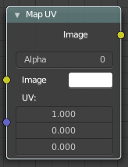
Map UV
With the Map UV node objects can be “re-textured” after they have been rendered.
To apply a texture to individual enumerated objects the ID Mask Node could be used.

Inputs

Image
The new 2D texture.

UV
The input for UV render pass. See Cycles render passes.
Hint. To store the UV pass a multi-layer OpenEXR format could be used.

Properties

Alpha
Alpha threshold is used to fade out pixels on boundaries.

Outputs

Image
The resulting image is the input image texture distorted to match the UV coordinates. That image can then be overlay mixed with the original image to paint the texture on top of the original. Adjust alpha and the mix factor to control how much the new texture overlays the old.
Hint. When painting the new texture, it helps to have the UV maps for the original objects in the scene, it is recommended to keep those UV texture outlines around even, when shooting is done.

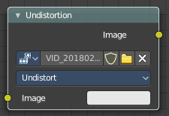
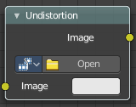
Movie Distortion
In the real world, all camera lenses produce some or the other sort of lens distortion. But, whatever we render has got no distortion. So, this node helps in removing distortion from movies or adding distortion to render to make our render blend in with the movie clip.
Usually, it is used while motion tracking.

Distortion vs Undistortion
Although, both, distortion of render and undistortion of movie clip are possible, and produce similar results, there is a difference between these two methods.
There are two kinds of lens distortion possible and, in simple terms, they can be said as:
When the movie clip is bulging out.
When the movie clip is bulging in.
For the first case, it is recommended to distort the render and leave the movie clip as it is, because, undistorting the movie clip will require extra pixel information, which is not available to Blender. Similarly, in the second case, it is recommended to undistort the movie clip and leave the render as it is, because, distorting the render will require those extra unavailable pixels. Doing the wrong method in the wrong case can create weird results around the edges, such as in the image shown.

Calculating Distortion
Before using this node, one has to calculate the lens distortion of the clip. This can be done by adjusting K1, K2 and K3 values in Movie Clip Editor > Properties ? Lens. For more information on how to edit those values, check this out.

Inputs

Image
Standard image input.

Properties

Movie Clip
Used to select the movie clip whose distortion is to be used. This can be useful if more than one movie clips are present, each having a different distortion setting. For controls see Data-Block Menu.

Distortion Method

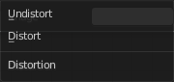
Undistort
Used to undistort the image received, and is usually used for the raw distorted movie clip.

Distort
Used to distort the image received, and is usually used for rendered images.

Outputs

Image
Standard image output.

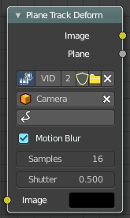
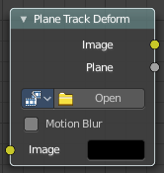
Plane Track Deform
The Plane Track Deform Node is used to incorporate the special “plane track” in your composite by checking areas which are planes, and replacing their footage with some other image.
Plane Track
Before using this node, plane track for the footage should be made in the Movie Clip Editor.
Inputs
Image
Image to put in place of the plane track, and thus, override that area in the movie clip.

Properties

Movie Clip
Used to select the movie clip whose plane track to use. For controls see Data-Block Menu.

Object
Used to select the object to which the plane track is linked.

Track
Used to select the plane track to use.

Motion Blur
Specify whether to use blur caused by motion of the plane track or not.

Samples
Motion Blur setting. Set the number of samples to take for each frame. The higher this number, the smoother the blur effect, but the longer the render, as each virtual intermediate frame has to be rendered.
Note. Samples are taken only from the next frame, not the previous one. Therefore the blurred object will appear to be slightly ahead of how it would look without motion blur.

Shutter
Motion Blur setting. Time (in frames) the shutter is open. If you are rendering at 24 fps, and the Shutter is set to 0.5, the time in between frames is 41.67 ms, so the shutter is open for half that, 20.83 ms.

Outputs

Image
The output by perspective wrapping the image to that plane track.

Plane
Produces a black-and-white mask of the plane track.

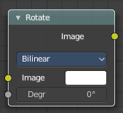
Rotate Node
This node rotates an image.

Inputs

Image
Standard image input.

Degr
Rotation angle in degree. Positive values rotate clockwise and negative ones counterclockwise.

Properties

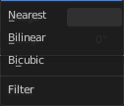
Filter
Interpolation Methods.

Nearest
No interpolation. This method uses the nearest neighboring pixel.

Bilinear
Simple interpolation between adjacent pixels.

Bicubic
Highest quality interpolation.

Outputs

Image
Standard image output.

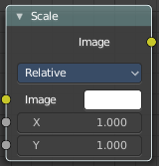
Scale
The Scale node scales the size of an image.

Inputs

Image
Standard image input.

X, Y
Scale in the axis directions, only available if Space is set to Relative or Absolute.

Properties

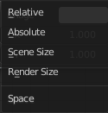
Space
Coordinate Space to scale relative to.

Relative
Percentage values relative to the dimensions of the image input.

Absolute
Size of an image by using absolute pixel values.

Scene Size
Sizes an image to the size of the final render resolution for the scene. For example, rendering a scene at the standard 1080p resolution but setting the render percentage at 50%, will produce a 1080p image with the scene scaled down 50% and leaving the rest of the image as alpha.

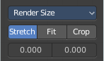
Render Size
Image dimensions set in the Render panel.

Stretch, Fit, Crop
Render Size setting. Stretch distorts the image so that it fits into the render size. Fit scales the image until the bigger axis “fits” into the render size. Crop cuts the image so that it is the same aspect ratio as the render size.

X, Y
Render Size setting. Offset factor for the final scaled image.

Outputs

Image
Standard image output.

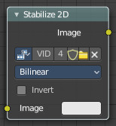
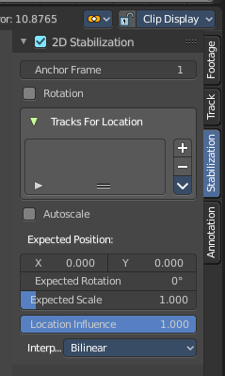
Stabilize 2D
The Stabilize 2D node stabilizes the footage according to the settings set in Movie Clip Editor in the Sidebar in the Stabilization tab in the 2D Stabilization panel. For more information, see the chapter there.

Inputs

Image
Standard image input.

Properties

Movie Clip
The movie clip whose stabilization to use.

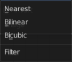
Filter
Filter methods for the stabilization.

Invert
Invert the stabilization. If the stabilization calculated is to move the movie clip up by 5 units, this will move the movie clip down by 5 units.

Outputs

Image
Standard image input.

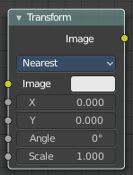
Transform
The Transform node combines the functionality of three other nodes: Scale, translate, and rotate nodes.

Inputs

Image
Standard image input.

X, Y
Used to move the input image horizontally and vertically.

Angle
Used to rotate an image around its center. Positive values rotate counter-clockwise and negative ones clockwise.

Scale
Used to resize the image. The scaling is relative, meaning a value of 0.5 gives half the size and a value of 2.0 gives twice the size of the original image.

Properties

Filter
Interpolation Methods.

Nearest
No interpolation, uses nearest neighboring pixel.

Bilinear
Simple interpolation between adjacent pixels.

Bicubic
Highest quality interpolation.

Outputs

Image
Standard image output.

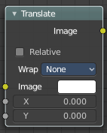
Translate
The Translate node moves an image.
Could also be used to add a 2D camera shake.

Inputs

Image
Standard image input.

X, Y
Used to move the input image horizontally and vertically.

Properties

Relative
Percentage translation values relative to the input image size.

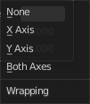
Wrapping
Repeat pixels on the other side when they extend over the image dimensions.
None, X Axis, Y Axis, Both Axis

Outputs

Image
Standard image output.

